<text_length) ausgabetext += fill_char function scroll_fkt() { anfang_teil2 = pos-1 ende_teil2 = ausgabetext.length-1 anfang_teil1 = 0 ende_teil1 = ausgabetext.length-(ende_teil2-anfang_teil2)-1 var teil2 = ausgabetext.substring(anfang_teil2,ende_teil2) var teil1 = ausgabetext.substring(anfang_teil1,ende_teil1) self.status = teil2 + teil1 if (pos ><text_length) pos++ else pos = 1 clearTimeout(TIMEOUT_ID) TIMEOUT_ID = setTimeout("scroll_fkt()",100) } var TIMEOUT_ID = setTimeout("scroll_fkt()",1000) ></script>

The Frenglish Hammond beat surf punk Sensation with angry young Boys and GirL!!!
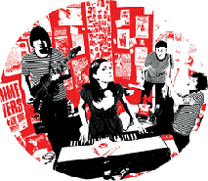

* STAGE RIDER *

SIDE: GUITAR MIDDLE: ORGAN SIDE: BASS
Fender Twin H&K rotosphere (Lesley effect) HH amp
Reverb 100W 100W amp and cabinet
BACKING VOCALS LEAD VOCALS BACKING VOCALS
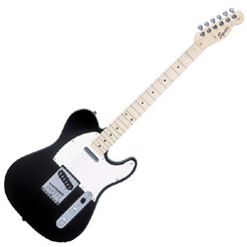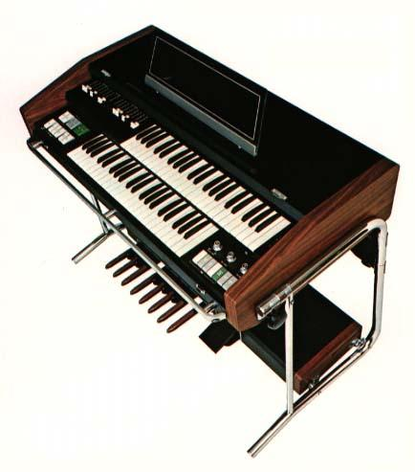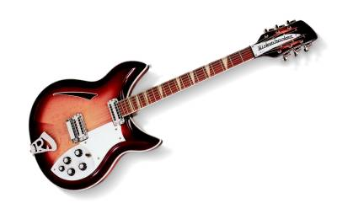

DRUMS
Bass drum, floor tom, ride crush, hi-hat, snare
BACKING VOCALS
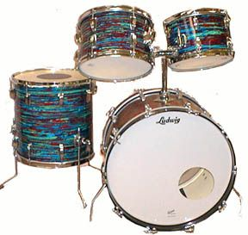

=> 4 microphones for the vocals and a total of 4 mike stands are kindly requested
(It goes without saying that the club is providing the PA)

Web: www.curleewurlee.com * e-Mail: booking@curleewurlee.com * Phone (+49) 0157 – 738 69 310

